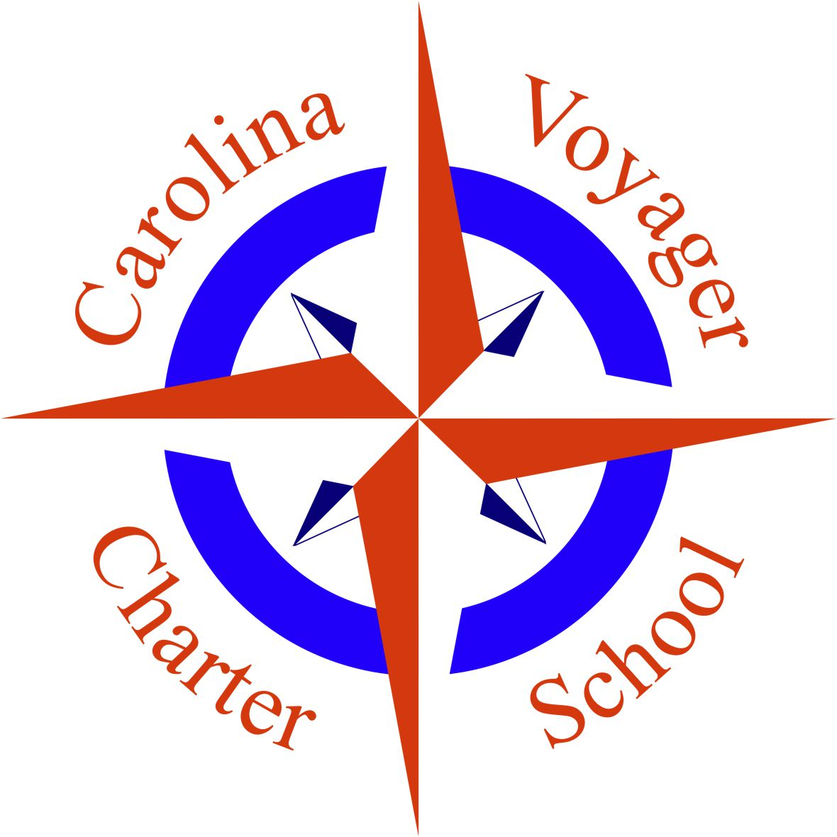
REQUEST FOR PROPOSALS

ISSUE DATE:
LAST DAY FOR QUESTIONS: One week before date due
DUE DATE: 3/31/2023

PROCUREMENT FOR: School furniture and fixtures to outfit new school facility for Carolina Voyager Charter School.
Sealed bids will be received at the location and time stated herein.
MAILING ADDRESS: 721 Wappoo Road, Charleston, SC 29407
STREET ADDRESS: 721 Wappoo Road, Charleston, SC 29407

PROPOSAL REQUIREMENTS

A. Technical Proposal

1. General Requirements
The purpose of the Proposal is to gather recommendations and pricing options for outfitting the planned building facility of Carolina Voyager Charter School with furniture and fixtures needed to operate a school facility. The cost should include the entire scope of outfitting the school, including but not limited to the cost of the furniture, fixtures, installation and installation materials, labor, delivery & shipping, etc. and broken down by line item.
The Proposal should be prepared simply and economically, providing a straightforward, concise description to satisfy the requirements of the request for proposals

2. Similar Engagements with other Charter School Entities
List the most recent jobs performed similar to the engagement described in this request for proposal. Indicate the scope of work, date completed, and the name and telephone number of the principal client contact for reference.

3. Timing of delivery
The new school facility is slated to begin construction in January 2023 with an estimated completion date of Feb 2024. The outfitting of the school with furniture and fixtures is to be completed by May 2024 in time for the preparation for the upcoming school year that begins in June 2024.

B. Requirements from Carolina Voyager Charter School

In order to customize the facility outfit, Carolina Voyager will submit building plans to all proposing firms. Any additional plans and drawings as the building is permitted and constructed will be shared with all proposing firms. The School’s administration and/or board of directors will be available for any consultation discussions needed to prepare a proposal.

B. Sealed Dollar Cost Bid / Total All-Inclusive Maximum Price

The sealed dollar cost bid should contain all pricing information relative to performing the request and requirements. The total all-inclusive maximum price to be bid is to contain all direct and indirect costs including all out of pocket expenses. Carolina Voyager Charter School will not be responsible for expenses incurred in preparing and submitting the technical proposal or the sealed dollar cost bid. Such costs should not be included in the proposal.

EVALUATION PROCEDURES

A. Evaluation Committee
Proposals submitted will be evaluated by a Furniture & Fixtures Proposal Review Committee named by the Carolina Voyager Charter School Board of Directors.

B. Review of Proposals
The Proposal Review Committee will use a point formula during the review process to score proposals. Each member of the Proposal Review Committee will first score each proposal by each of the criteria described. The full Proposal Review Committee will then convene to review and discuss these evaluations and to combine the individual scores to arrive at a composite score for each proposal.

After the composite score for each proposal has been established, the sealed dollar cost bid will be opened and additional points will be added to the technical score based on the price bid. The maximum score for price will be assigned to the firm offering the lowest total all-inclusive maximum price. Appropriate fractional scores will be assigned to other proposers.

C. Evaluation Criteria
Proposals will be evaluated using three sets of criteria. Proposals meeting the mandatory criteria will have their proposals evaluated and scored for both technical qualifications and price. The following represent the principal selection criteria that will be considered during the evaluation process.
1. Mandatory Elements
a. The proposing firm has no conflict of interest with Carolina Voyager Charter School
b. The proposing firm has provided similar scope of work for peer schools
c. The proposing firm has been in operation for at least 5 years
d. The proposing firm adheres to the instructions in this request for proposal on preparing and submitting the proposal.
e. The proposing firm provides references (minimum of 3) of similar institutions (schools of similar size) that Carolina Voyager can contact
f. The proposing firm must guarantee that the timing of delivery referenced earlier will be met.

2. Technical Quality: (Maximum Points - 70)

a. Expertise and Experience
(1) The proposing firm’s past experience and performance on comparable engagements (details will come from references)
(2) The quality of the firm's professional personnel to be assigned to the engagement and the quality of the firm's presentation

3. Price: (Maximum Points - 30)
COST WILL NOT BE THE PRIMARY FACTOR IN THE SELECTION

D. Oral Presentations
During the evaluation process, the Proposal Review Committee may, at its discretion, request any or all presenting firms to make oral presentations. Such presentations will provide firms with an opportunity to answer any questions the Review Committee may have on a firm's proposal. Not all proposing firms may be asked to make such oral presentations.

E. Final Selection
Carolina Voyager Charter School Board of Directors will select a firm for award after receiving a recommendation of the Proposal Review Committee. Following notification of the firm selected, it is expected a contract will be executed between both parties.

F. Right to Reject Proposals
Carolina Voyager Charter School Board of Directors reserves the right without prejudice to reject any or all proposals.

