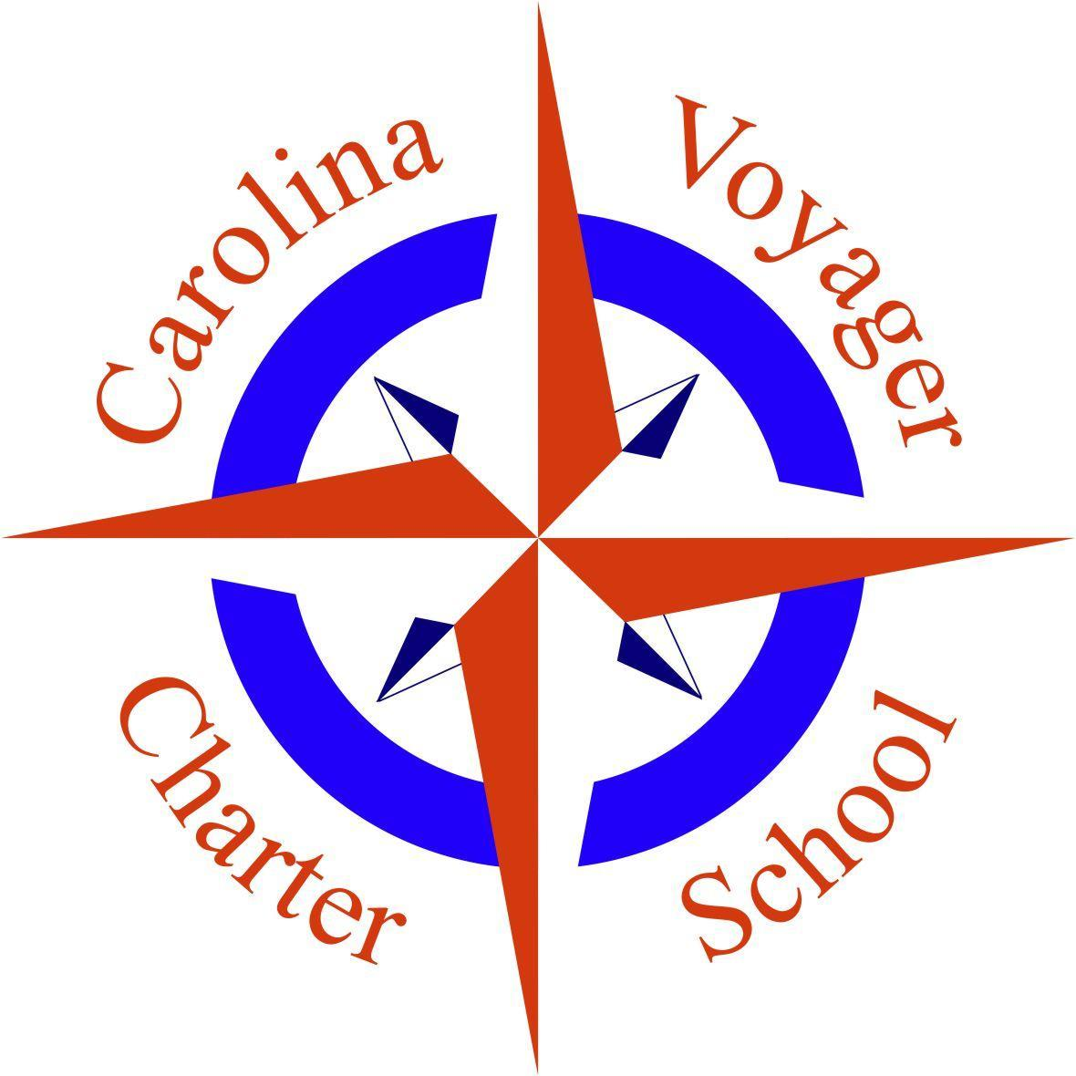
Carolina Voyager Charter School
Board of Directors Meeting
August 9, 2022 3:00 p.m.
721 Wappoo Road, Building 101

Meeting Link:
https://cofc.zoom.us/j/7694400251

Meeting ID: 769 440 0251

The mission of the Carolina Voyager Charter School is to create resilient learners and empathetic citizens by fostering, supporting, and promoting excellence in learning in an engaging, technology rich environment balanced with the social and emotional development of the 21st century student.

Members Present: Ashleigh Parr, Kelly Lake, Harry Walker, Neil Oliver, Shanequa Frost Whitney Quick (via zoom)
Guests Present: Anthony Holland, Tricia Lisinski, John Kabel, Courtney Snype

1. Call to Order/Welcome/Pledge of Allegiance
The meeting was called to order by Ashleigh Parr at 5:09 p.m.
2. Mission Statement
The mission statement was read by Ashleigh Parr.
3. Review and approval of August 9, 2020 agenda*
Shanequa Frost made a motion to approve the August 9, 2022 agenda. Kelly Lake seconded the motion. The motion passed unanimously.
4. Review and approval of July 12, 2022 meeting minutes*
Kelly Lake made a motion to approve the July 12, 2022 meeting minutes. Ashleigh Parr seconded the motion. The motion passed unanimously.
5. Review and approval of July 21, 2022 meeting minutes*
Harry Walker made a motion to approve the July 21, 2022 meeting minutes. Shanequa Frost seconded the motion. The motion passed unanimously.
6. Introduction of Guests and Public Comment
There was no public comment at the meeting.
7. Finance Update
- Final review of FY23 budget*
Harry Walker made a motion to table to the final review of the FY 23 budget pending retirement estimates being added for all staff members. Kelly Lake seconded the motion. The motion passed unanimously.
- Review and approval of July 2022 budget report*
Neil Oliver presented a review of the July budget. Harry Walker made a motion to approve the July 2022 budget report. Neil Oliver seconded the motion. The motion passed unanimously.
8. School Leader Report
- Month of July activities - Building preparation, school tours, materials, class schedules finalized, hiring staff, onboarding new staff members
- August 10th - First day for all staff
- August 15th - Meet and Greet 4:00-6:00 p.m.
- August 17th - First day of School
- Enrollment Numbers Kindergarten (33), First Grade (43), Second Grade (44), Third Grade (46), Fourth Grade (46), Fifth Grade (43), Sixth Grade (44), Seventh Grade (43), Eighth Grade (41) - Current enrollment is 383 students with 12 invites sent out awaiting reply
- Staff Vacancies - Middle School, First Grade
9. Discussion/Information Items
- Nomination Committee for Appointed Board Positions
Harry Walker reported on progress made by the Nomination Committee. The Committee has received three letters of interest. All three candidates will be interviewed by the Committee. Two persons will be recommended for consideration for the appointed Board positions. Board members will cast votes for the slate of candidates via email prior to the September Board Meeting. New Board Members will be sworn in at the September meeting.
- Building update* - The lease extension has been approved, permitting on the new school building is moving forward, the clearing of the lot should begin in September. The final plans were shared with the Board Members and participants on the zoom call. Harry Walker made a motion to approve the building plan for the new school. Ashleigh Parr seconded the motion. The motion passed unanimously.
- Board Retreat - Ashley Parr shared information on a possible board retreat. She will be investigating the details for a possible board retreat in coordination with personnel associated with the College of Charleston. She will report back to the board at the September meeting.
10. Executive Session
Neil Olilver motioned to go into executive session. Shanequa Frost second the motion. The motion passed unanimously
- School Leader Goals
- Board Documents
- Establish Board Committees*
- Communications with the Board*
- Legal Counsel
11. Action Items from Executive Session:
Kelly Lake made a motion for Whitney Quick to chair a Board Document Committee to begin revising Board Documents. The first manual to be reviewed will be the Board Governance Manual. Ashleigh Parr seconded the motion. The motion passed unanimously.
Whitney Quick made a motion to formally adopt the following ad hoc committees - Budget Committee, Board Member Search Committee, and Building Committee . Ashleigh Parr seconded the motion. The motion passed unanimously.
Shanequa Frost made a motion to establish the following Board Communications policy. Communications to the Board will be shared with all Board Members. Ashleigh Parr will take the lead on responding to all emails. Ashleigh Parr seconded the motion. The motion passed unanimously.
12. Adjourn
Harry Walker made a motion to adjourn the meeting at 6:50 p.m. Kelly Lake seconded the motion. The motion passed unanimously.

Public Comment
Please fill out the form below if you would like to make a public comment during the next Carolina Voyager Board meeting. Public comments must be kept to three minutes in length. Please refer to the "CVCS 21-22 Board Meeting Calendar" for further rules and procedures regarding public comment.
Link for Public Comment: HERE or email: Board@carolinavoyager.org, subject “Voyager Board Meeting - date”

