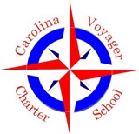
Carolina Voyager Charter School
Board of Directors Executive Session Agenda
November 5, 2018, 4:00
721 Wappoo Road, Building 101 Room 140

The mission of the Carolina Voyager Charter School is to create resilient learners and empathetic citizens by fostering, supporting, and promoting excellence in learning in an engaging, technology rich environment balanced with the social and emotional development of the 21st century student.

- Call to Order/Welcome
- Approval of Agenda*
- Executive Session- student matter
- Adjourn

*Denotes Board action to be taken

